Citizen Perception Survey Report: Insights on Government Policies and Performance in Niger State.

**INTRODUCTION**

This report presents the findings of the Citizen Perception Survey on Government Policies, Programs, and Projects across the 25 Local Government Areas (LGAs) in Niger State, Nigeria. The survey collected data on public opinions regarding government performance, sector-specific challenges, infrastructure quality, and key policy issues, aiming to provide actionable insights into citizens’ perspectives.

**The report is structured into the following key Analysis:**

**1.Descriptive Analysis**

Demographic Breakdown: Analyze gender, age, marital status, educational qualifications, and occupations to understand the respondent population.

Local Government Area (LGA) Representation: Assess the distribution of responses across the 25 LGAs.

**2.Performance Rating Analysis**

Overall Government Performance: Examine the distribution of ratings on government performance.

Sector-Specific Ratings: Evaluate ratings on challenges like unemployment, poverty, insecurity, healthcare, and education quality.

Infrastructure Ratings: Assess the quality ratings for roads, water supply, electricity, and healthcare facilities.

**3.Sentiment Analysis**

Opinions on Government Policies: Analyze open-ended responses on the most impactful policies and pressing issues to identify recurring themes.

Suggestions for Improvement: Use text analysis on suggestions for improving government performance.

**DATA VISUALIZATION AND INSIGHTS**

This section presents visual representations of the survey data, aimed at enhancing the understanding of citizens' opinions on government policies and performance. The visualizations provided in this section offer a detailed look at demographic trends, performance ratings, and public sentiment, revealing key areas for policy and performance improvement.

**Descriptive Analysis**

**1.Gender Distribution of Survey Respondents:**

*The chart below shows that 66% of respondents were male, while 34% were female. This gender distribution indicates a male-dominated response pattern in the survey, which could imply a higher male engagement or representation in the survey process.*

*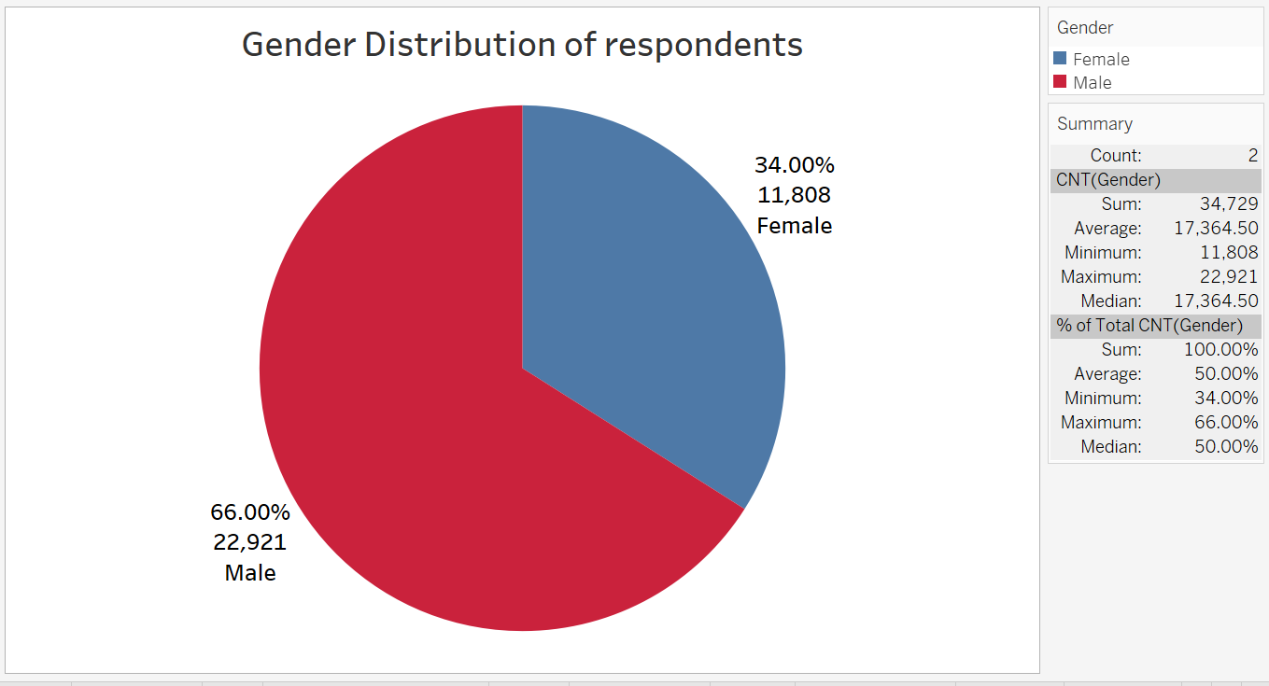****Figure 1 : Gender Distribution of Survey Respondents***

**2.Age Distribution of Survey Respondents:**

*The chart below illustrates the age distribution of the respondents. The data shows that 39.39% of respondents were between the ages of 26-35, making it the largest age group. The next most common age bracket was 36-45 years, representing 26.54% of respondents. Those aged 18-25 accounted for 21.43% of the survey, while 46–55-year-olds made up 9.57%, and respondents aged 55 and above represented only 3.08%. This distribution highlights a dominant presence of younger individuals in the survey, with 78.92% of respondents falling within the 18-45 age range.*

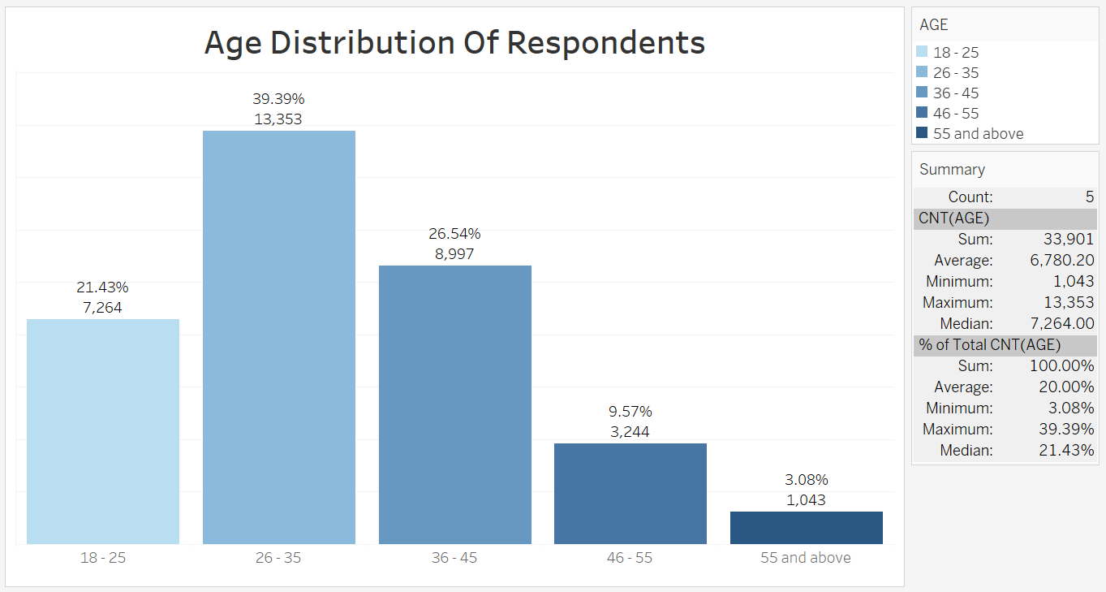

**Figure 2: Age Distribution of Survey Respondents**

**3.Marital Status of Survey Respondents:**

*The chart below illustrates the marital status distribution of survey respondents. The data indicates that 60.10% of respondents were married, 31.64% were single, 5.62% were divorced, and 2.64% were widowed.*

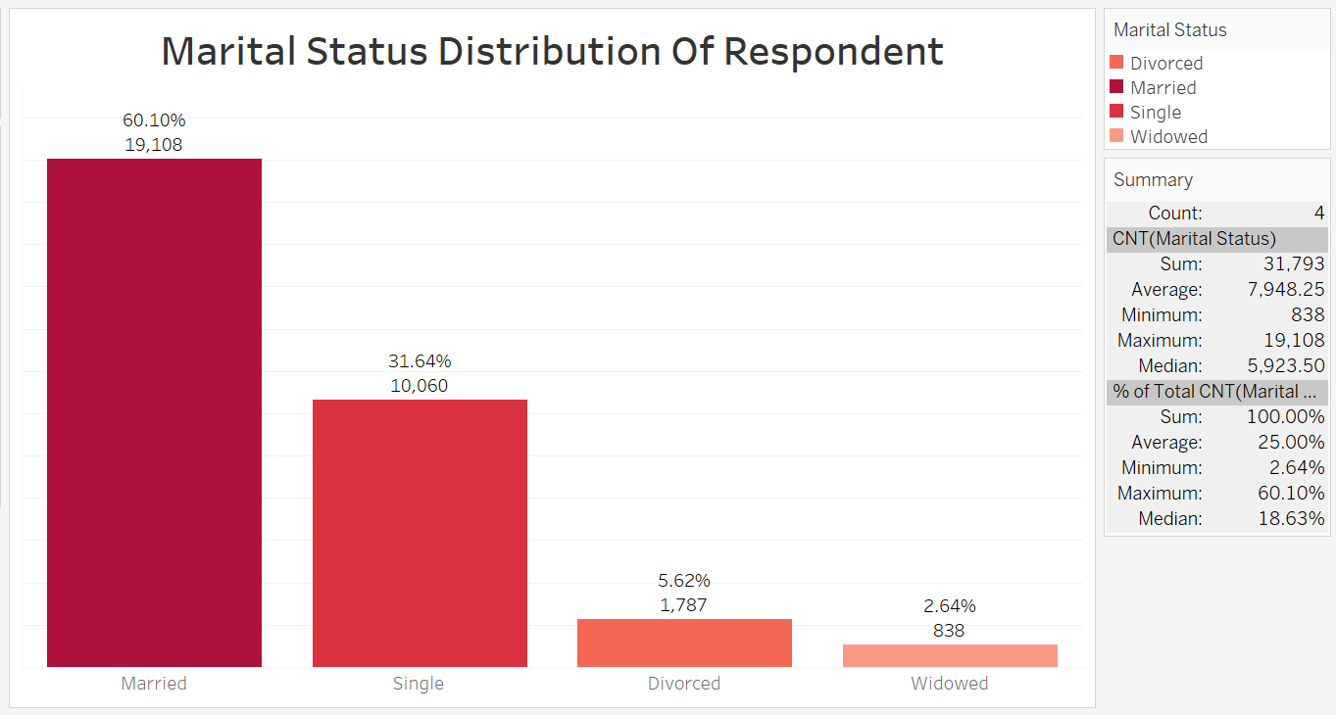

**Figure 3: Marital Status of Survey Respondents**

**4.Educational Qualifications of Survey Respondents:**

*The chart below illustrates the distribution of educational qualifications among survey respondents. The data indicates that 41.62% of respondents have completed secondary school, 24.79% have attained tertiary education, 18.10% have no formal education, and 15.49% have completed primary education.*

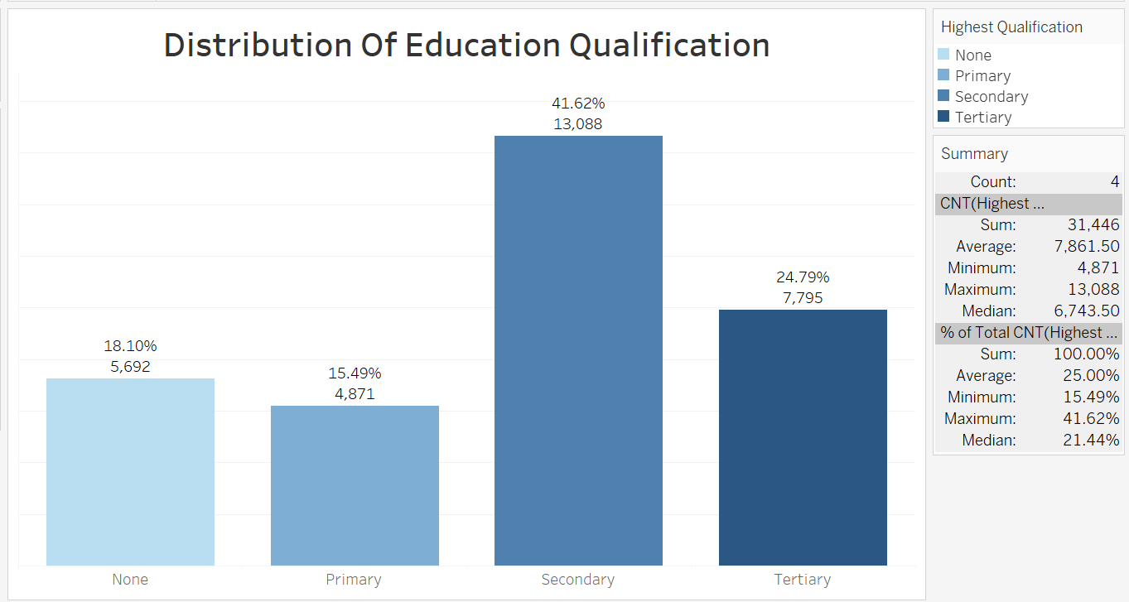

**Figure 4: Educational Qualifications of Survey Respondents**

**5.Occupational Distribution of Survey Respondents:**

*The chart below illustrates the distribution of occupations among survey respondents. The data shows that 10.54% are civil servants, 16.98% fall into the "Others" category, 17.39% are unemployed, 23.37% are students, and 31.72% are business owners.*

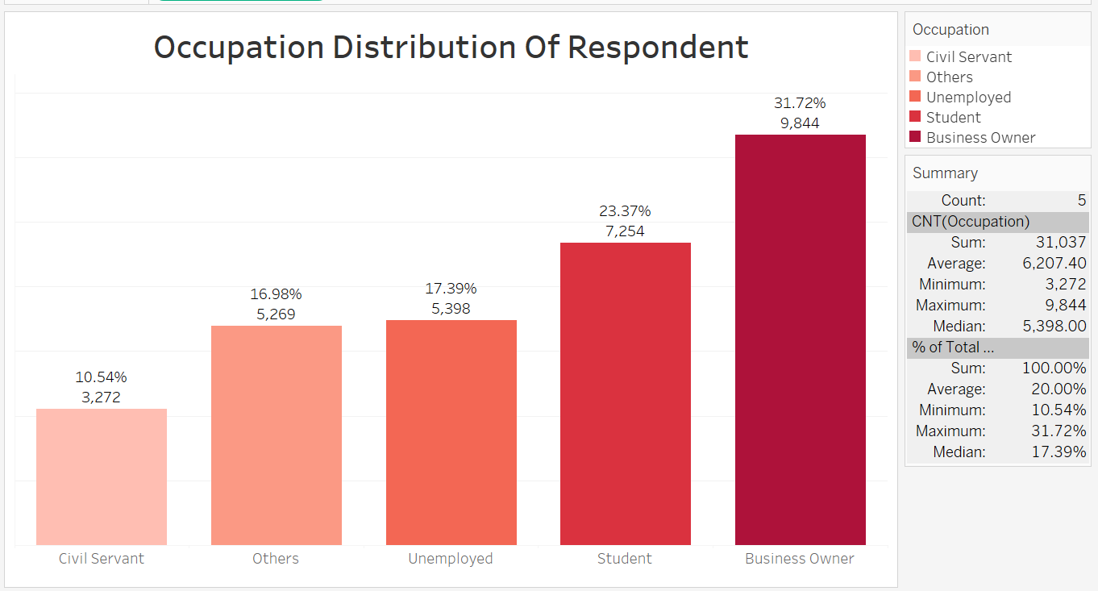

**Figure 5: Occupational Distribution of Survey Respondents**

**6.Resident Area Distribution of Survey Respondents:**

*The chart below illustrates the distribution of respondents based on their area of residence. The data shows that 81.90% reside in rural areas, while 18.10% live in urban areas.*

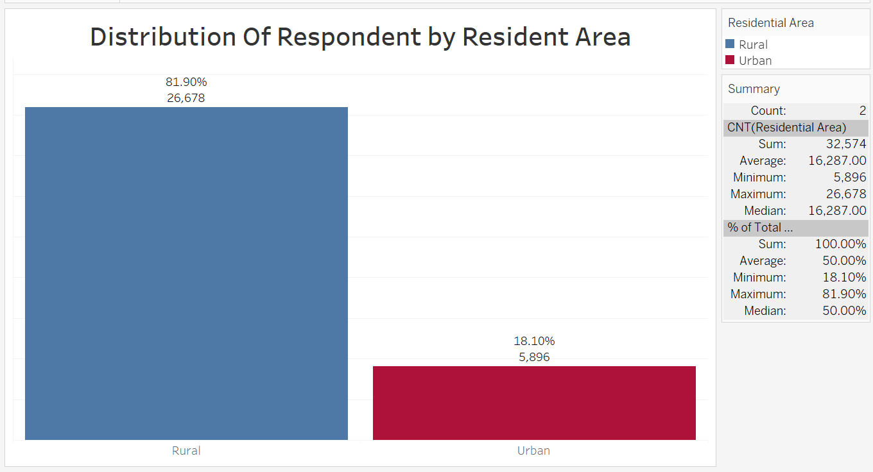

**Figure 6: Resident Area Distribution of Survey Respondents**

**7.Distribution of Responses Across Local Government Areas (LGAs):**

*The chart below illustrates the distribution of survey responses across the 25 LGAs in Niger State. Each LGA's representation in the survey is expressed as a percentage and the corresponding number of respondents.*

* *Suleja had the highest participation with 7.09% (2,470 respondents), reflecting its higher population density and potential urban engagement.*
* *Gbako followed closely, contributing 6.12% (2,133 respondents) of the total survey responses.*
* *Edati, Mokwa, Lapai, and Katcha collectively accounted for significant shares, ranging from 5.92% to 5.18%.*
* *Rural LGAs such as Rafi and Rijau had minimal representation, with only 0.57% (200 respondents) and 0.35% (121 respondents), respectively.*
* *Participation in other LGAs like Borgu, Lavun, and Magama ranged between 5.00% and 4.17%, showcasing a mix of moderate engagement.*

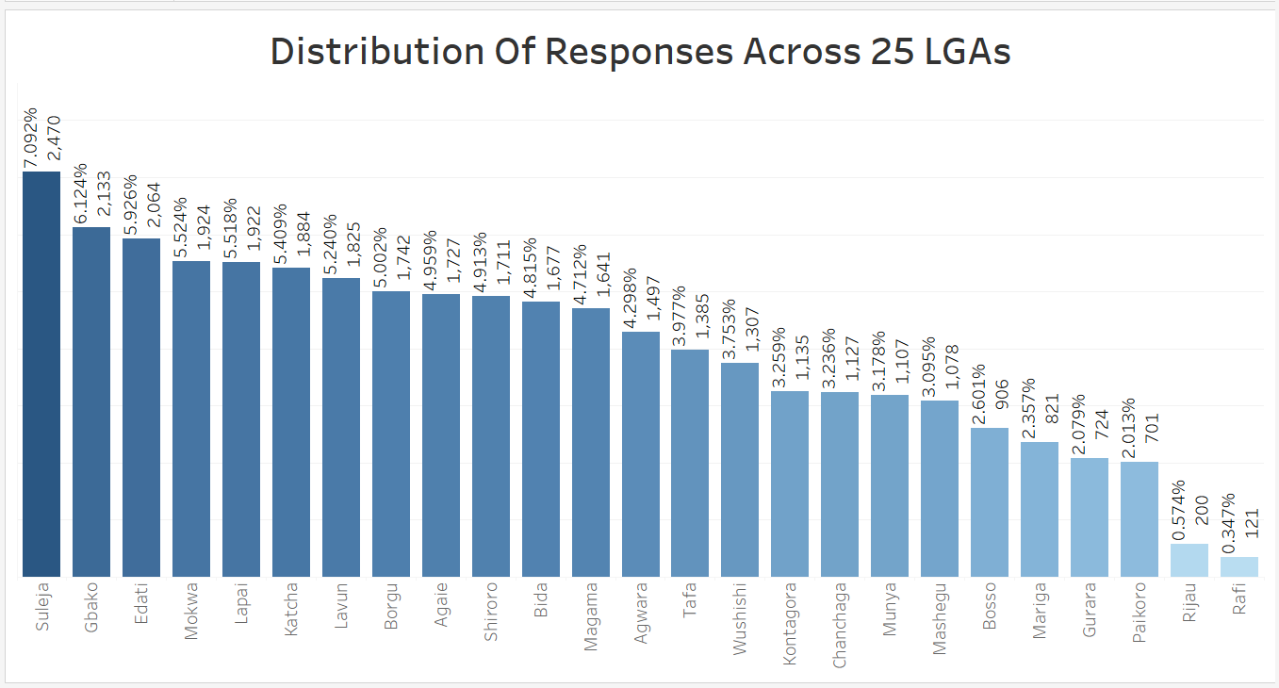

**Figure 7: Distribution of Responses Across Local Government Areas (LGAs)**

**Performance Rating Analysis**

**Citizens' Perception of Overall Government Performance:**

*The chart below illustrates the distribution of citizens' ratings on overall government performance. The data reveals that the largest group of respondents, 38.08%, rated the government’s performance as "Good." This was followed by 24.77% who rated it as "Excellent." Meanwhile, 22.18% rated the performance as "Fair," representing a neutral view.*

*On the other hand, 9.49% expressed dissatisfaction by rating the performance as "Poor," and 5.49% rated it as "Very Poor." This indicates that while there is a significant amount of positive perception, a portion of the population is either dissatisfied or neutral.*

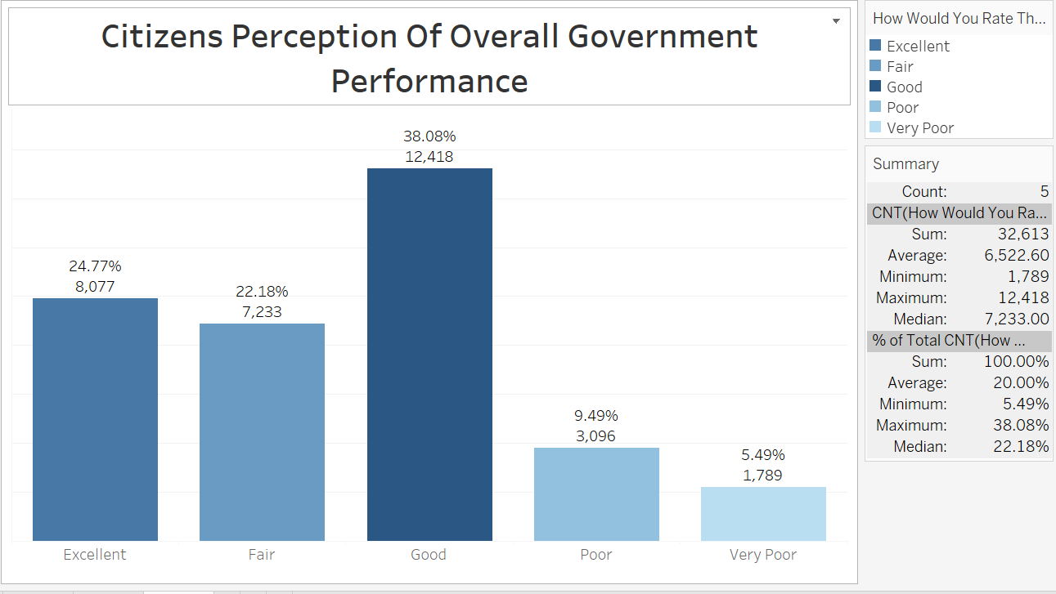

**Figure 8:Citizens' Perception of Overall Government Performance**

**Sector-Specific Ratings**

**1. Citizen Rating on Education Quality:**

*The chart below illustrates the distribution of citizens' ratings on the quality of education. The data shows that 14.42% of respondents rated the education quality as Effective, 37.32% rated it as Not Effective, 12.20% were Not Sure, 27.50% found it Slightly Effective, and 8.57% rated it as Very Effective.*

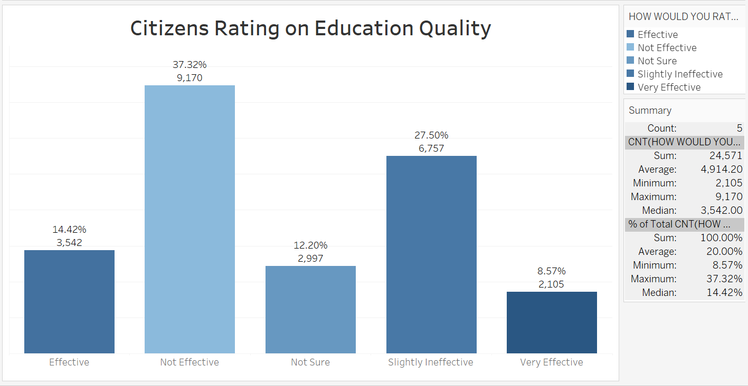

Figure 9:Citizen Rating on Education Quality

**2.Citizens Rating on Healthcare Services:**

*The chart below illustrates the distribution of citizens' ratings on healthcare services. The data shows that 15.89% of respondents rated healthcare services as Effective, 31.17% rated them as Not Effective, 13.37% were Not Sure, 32.78% found them Slightly Effective, and 6.79% rated them as Very Effective.*

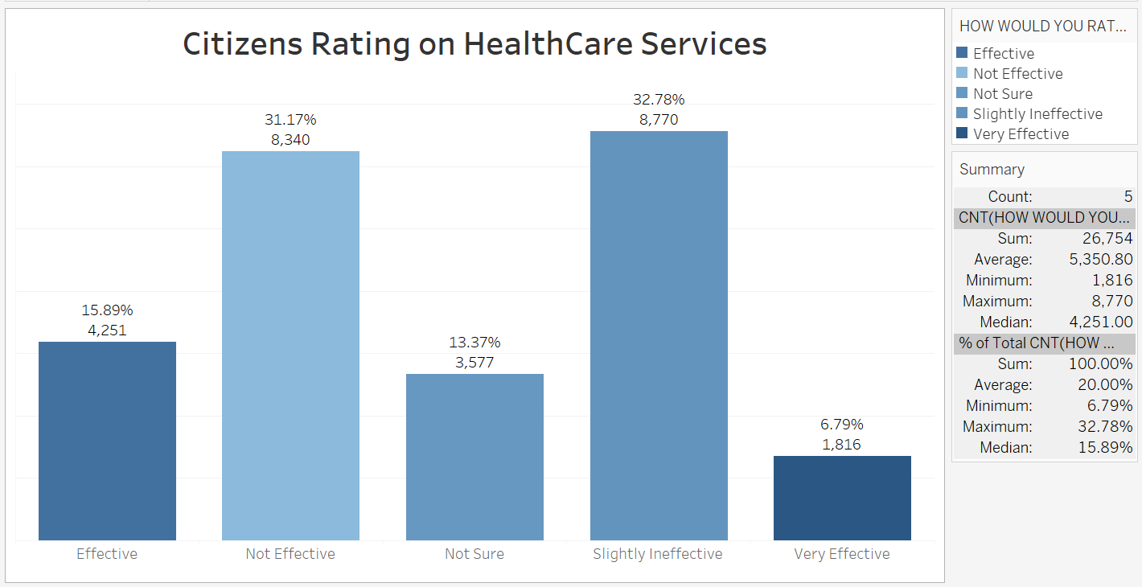

**Figure 10:Citizens Rating on Healthcare Services**

**3.Citizens' Rating on Poverty Alleviation:**

*The chart below illustrates the citizens' ratings on the effectiveness of poverty alleviation efforts. The data indicates that 12.15% of respondents found the efforts Effective, 40.30% considered them Not Effective, and 9.91% were Not Sure. Additionally, 31.23% rated the efforts as Slightly Ineffective, while 6.41% viewed them as Very Effective.*

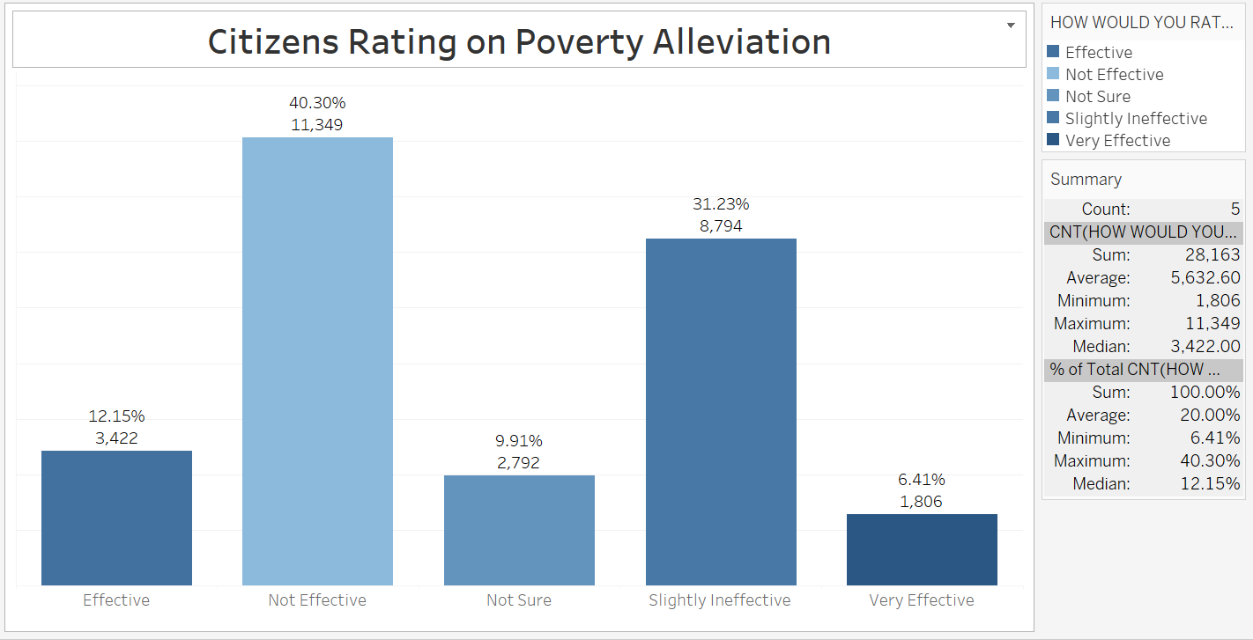

**Figure 11:Citizens' Rating on Poverty Alleviation**

**4.Citizens' Rating on Security and Safety:**

*The chart below illustrates the citizens' ratings on the effectiveness of security and safety measures. The data indicates that 15.00% of respondents found them Effective, 36.82% considered them Not Effective, and 12.36% were Not Sure. Additionally, 29.14% rated the measures as Slightly Ineffective, while 6.68% viewed them as Very Effective.*

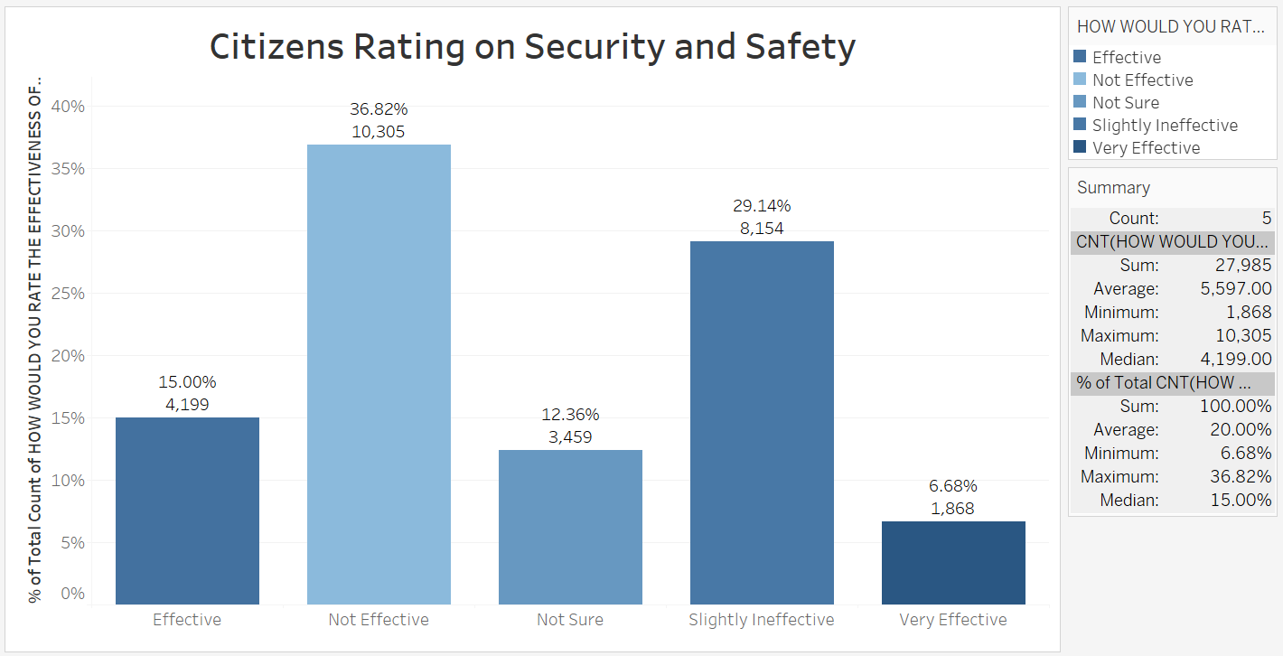

**Figure 12:Citizens' Rating on Security and Safety**

**5.Citizens' Rating on Unemployment Challenges:**

*The chart below illustrates the citizens' ratings on the effectiveness of government measures in addressing unemployment challenges. The data shows that 10.31% of respondents found these measures Effective, while 52.57% rated them as Not Effective. Additionally, 7.65% were Not Sure, 21.11% considered them Slightly Ineffective, and 8.36% rated them as Very Effective.*

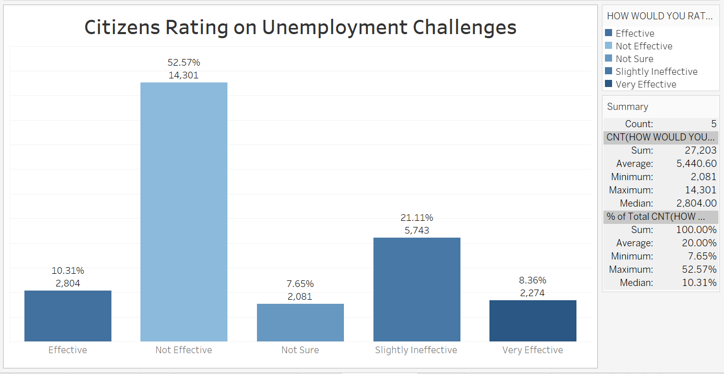

**Figure 13:Citizens' Rating on Unemployment Challenges**

**Infrastructure Ratings**

**1.Citizens Rating on Education Infrastructure:**

*The chart below illustrates the distribution of citizen ratings on education infrastructure. The data indicates that 12.93% of respondents rated the education infrastructure as Effective, while 34.77% considered it Not Effective. A total of 13.36% of respondents were Not Sure about its effectiveness. Additionally, 30.96% rated it as Slightly Ineffective, and 7.97% viewed it as Very Effective.*

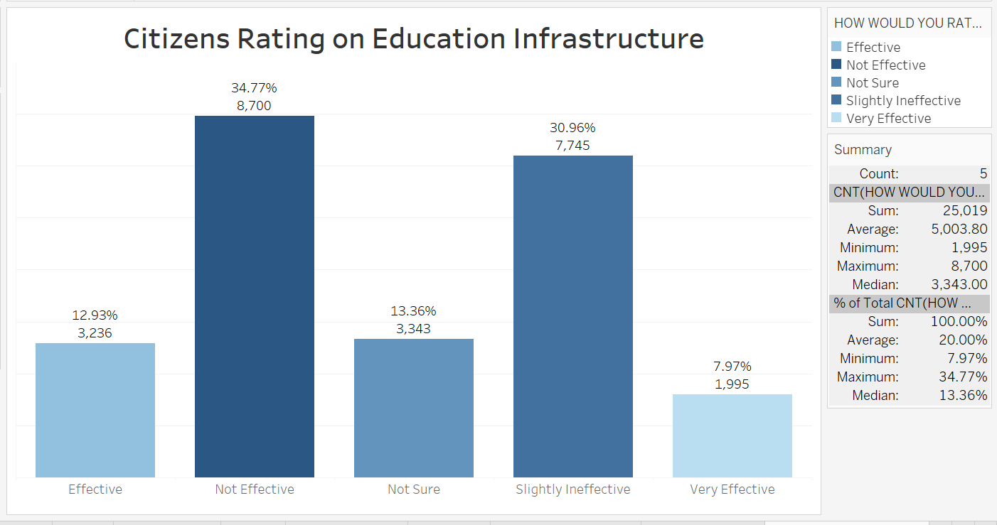

**Figure 14:Citizens Rating on Education Infrastructure**

**2.Citizens Rating on Electricity Infrastructure:**

*The chart below illustrates the distribution of citizen ratings on electricity infrastructure. The data indicates that 11.88% of respondents rated the electricity infrastructure as Effective, while 35.23% considered it Not Effective. A total of 14.48% of respondents were Not Sure about its effectiveness. Additionally, 32.54% rated it as Slightly Ineffective, and 5.86% viewed it as Very Effective.*

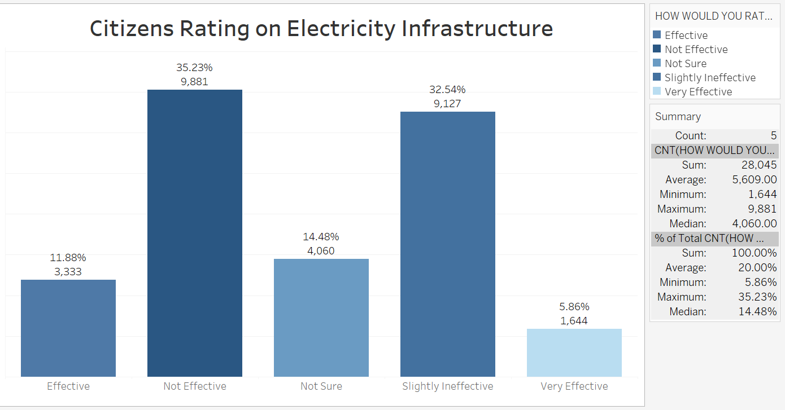**Figure 15:Citizens Rating on Electricity Infrastructure**

**3.Citizens Rating on Healthcare Infrastructure:**

*The chart below illustrates the distribution of citizen ratings on healthcare infrastructure. The data indicates that 14.43% of respondents rated the healthcare infrastructure as Effective, while 30.11% considered it Not Effective. A total of 15.01% of respondents were Not Sure about its effectiveness. Additionally, 34.67% rated it as Slightly Ineffective, and 5.78% viewed it as Very Effective.*

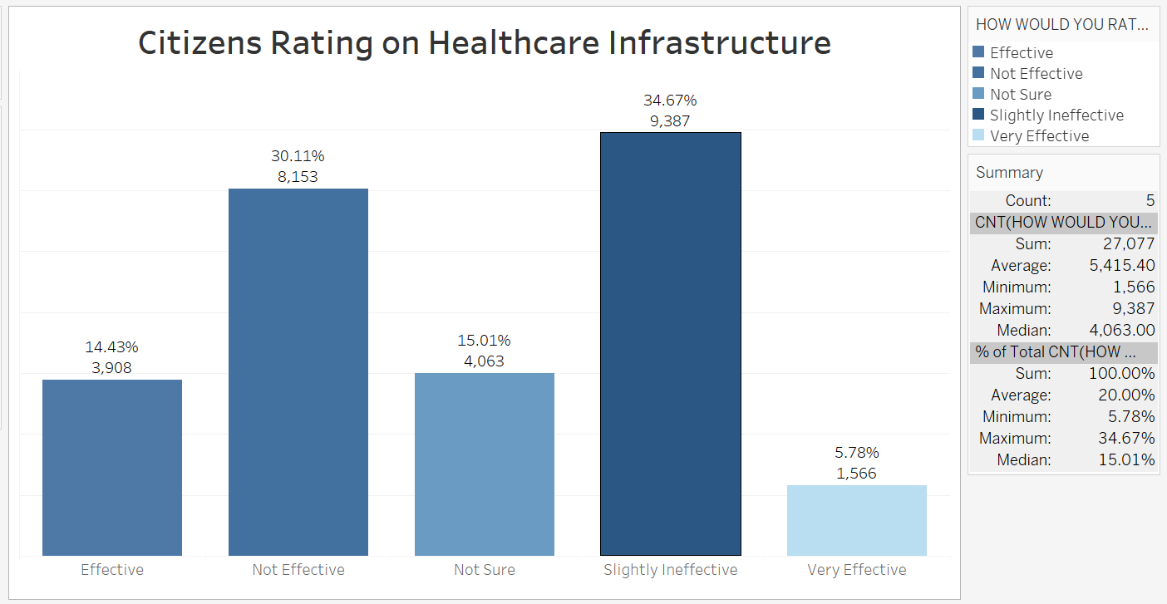

**Figure 16:Citizens Rating on Healthcare Infrastructure**

**4.Citizens Rating on Road Infrastructure:**

*The chart below illustrates the distribution of citizen ratings on road infrastructure. The data indicates that 12.30% of respondents rated road infrastructure as Effective, while 43.47% considered it Not Effective. A total of 9.23% of respondents were Not Sure about its effectiveness. Additionally, 27.77% rated it as Slightly Ineffective, and 7.24% viewed it as Very Effective.*

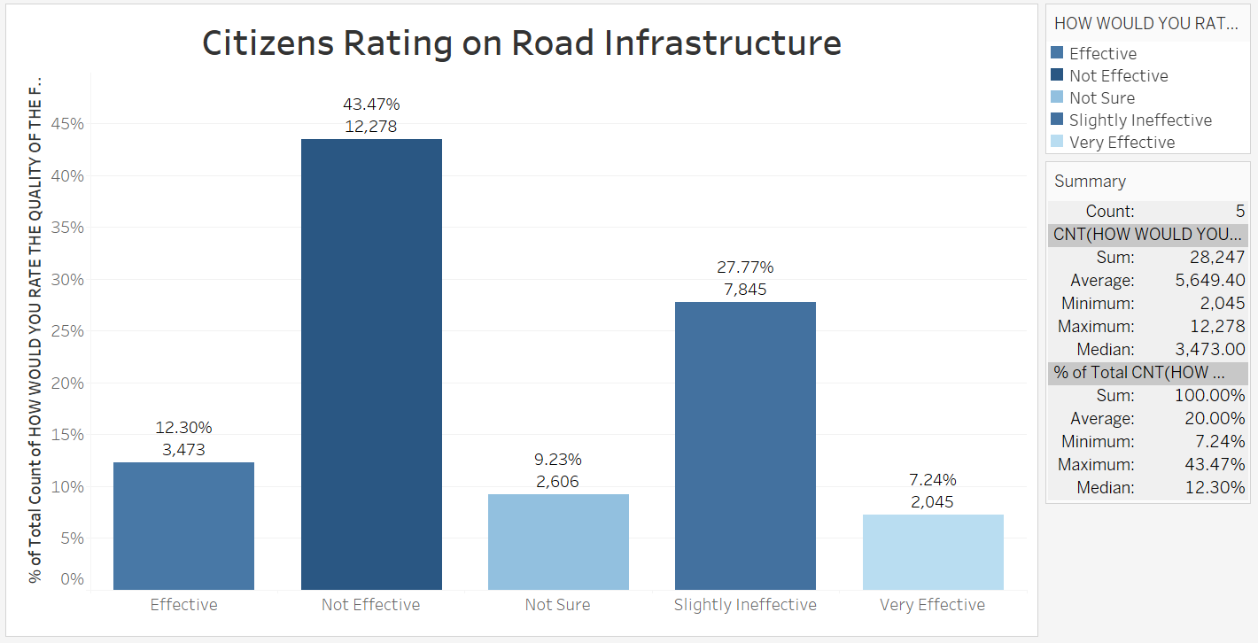

**Figure 17:Citizens Rating on Road Infrastructure**

**5.Citizens Rating on Water Infrastructure:**

*The chart below illustrates the distribution of citizen ratings on water infrastructure. The data indicates that 12.10% of respondents rated water infrastructure as Effective, while 34.14% considered it Not Effective. A total of 11.55% of respondents were Not Sure about its effectiveness. Additionally, 37.63% rated it as Slightly Ineffective, and 4.58% viewed it as Very Effective.*

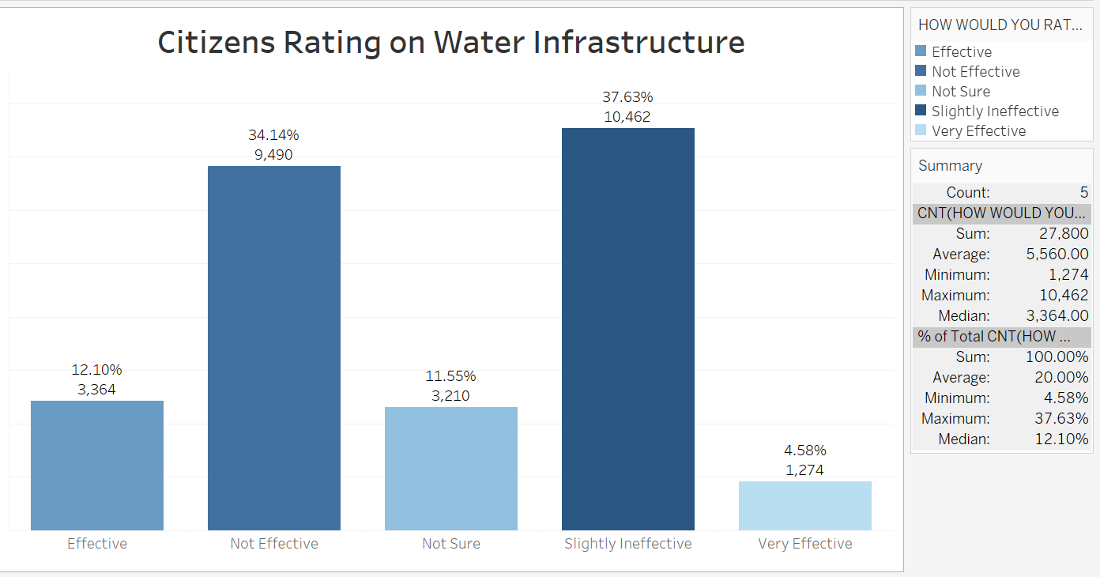

**Figure 18:Citizens Rating on Water Infrastructure**

**Additional Insights Report**

**1.Citizen Rating on Education Reform:**

*The chart below illustrates citizens' perceptions of education reform. The data indicates that 30.83% of respondents rated the reform as Good, making it the most common response. This is closely followed by 30.10%, who rated it as Fair. Meanwhile, 12.32% of respondents considered the reform to be Excellent. On the other hand, 20.50% rated it as Poor, and 6.24% as Very Poor.*

*This distribution highlights that while a significant portion of respondents perceive education reform positively, there remains a notable percentage who view it as needing improvement.*

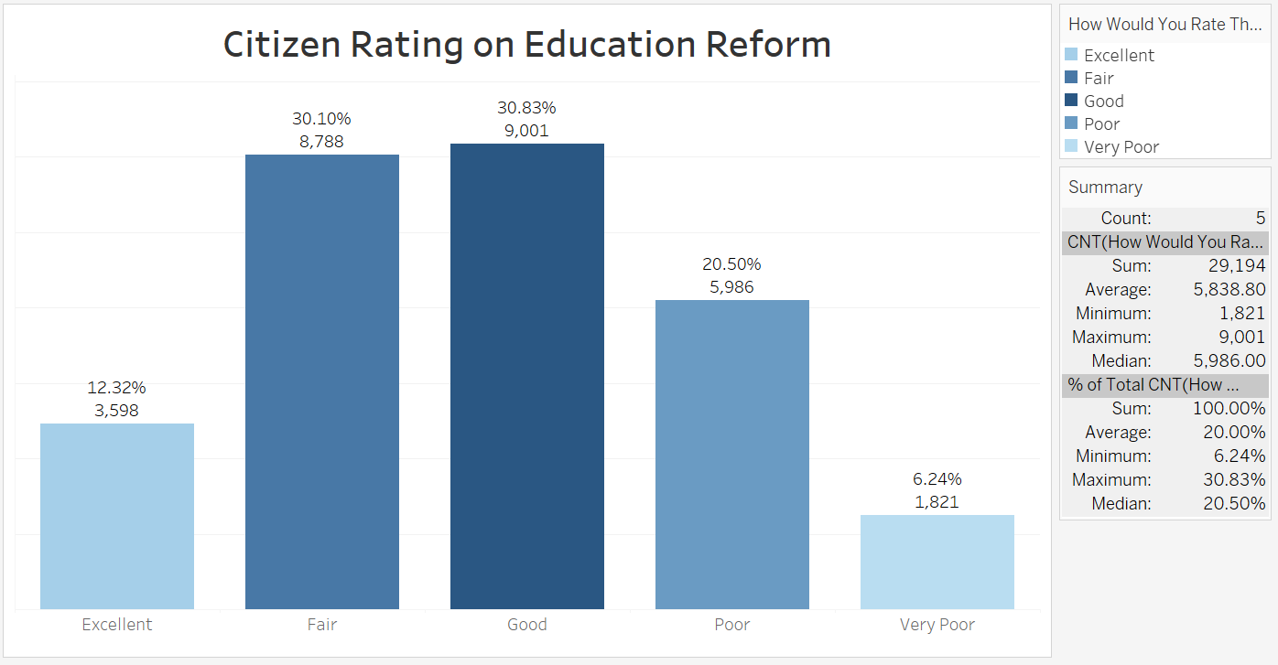

**Figure 19:Citizen Rating on Education Reform**

**2.Citizen Rating on Government Spending in Healthcare/Education/Infrastructure:**

*The chart below illustrates citizens' perceptions of government spending in healthcare, education, and infrastructure. The data shows that 27.07% of respondents rated the spending as Effective, while 19.13% considered it Not Effective. A significant 28.49% were Neutral in their assessment. Additionally, 18.26% rated it as Very Effective, and 7.05% expressed that it was Very Ineffective.*

*This distribution indicates that while some respondents view government spending in these sectors positively, there is a considerable portion that remains neutral or dissatisfied, suggesting a mixed perception of the effectiveness of these expenditures.*

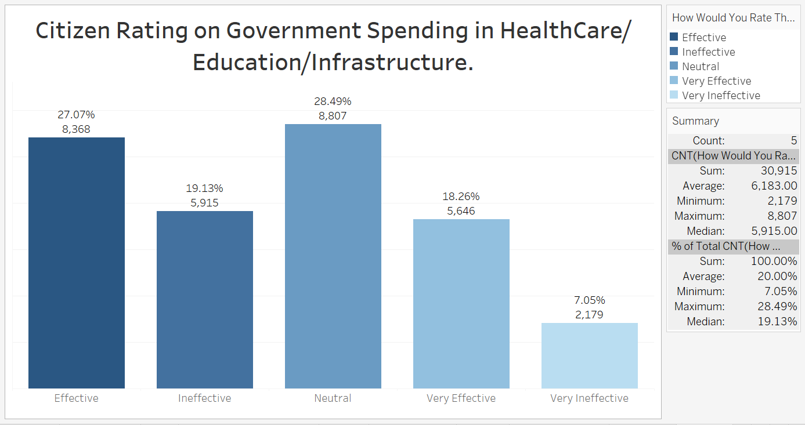

**Figure 20: Citizen Rating on Government Spending in Healthcare/Education/Infrastructure**

***3.Citizen Rating on Government Policies and Programs:***

*The chart below illustrates citizens' ratings of various government policies and programs. The data indicates that the Healthcare Initiative received the highest approval, with 30.82% of respondents recognizing it as impactful. Infrastructure Development followed, with 20.50% approval, while Education Reforms accounted for 18.90%.*

*Agricultural Revolution was rated by 13.76% of respondents, and Economic Empowerment garnered 10.90% approval. The lowest-rated policy was Security Measure, with only 5.12% of respondents endorsing its effectiveness.*

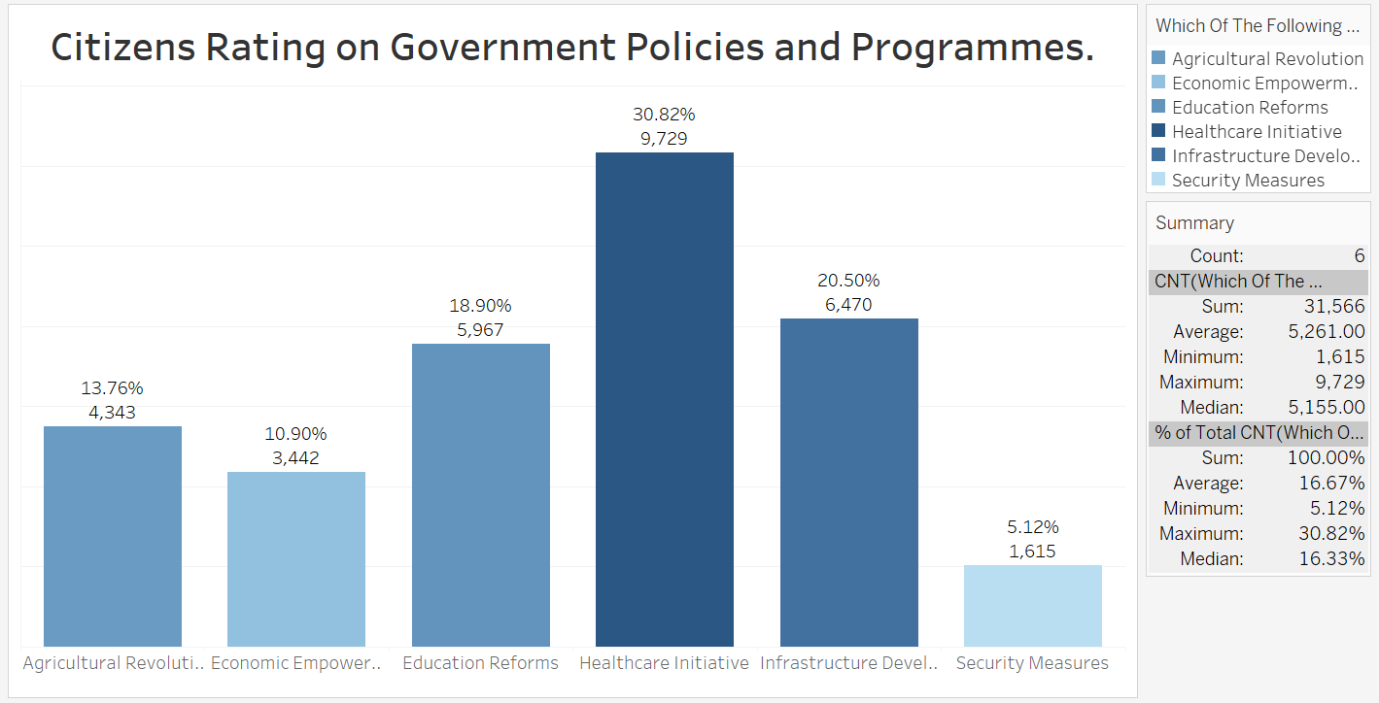

**Figure 21:Citizen Rating on Government Policies and Programs**

**Conclusion**

In summary, this comprehensive report highlights the diverse perspectives of citizens on key government initiatives, infrastructure, and service delivery across various sectors. The data reveals areas of success as well as critical gaps that need attention, reflecting the sentiments and priorities of the populace/citizens. These insights provide a roadmap for informed decision-making and continuous improvement in governance and public service.